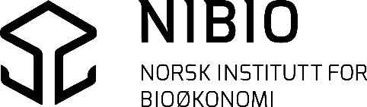
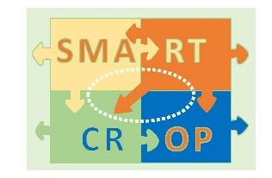

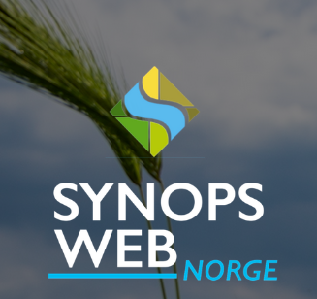
User guidance v. 1.1 (draft pr 24.11.2022)

SYNOPS WEB Norge is an online tool that can help the advisor or farmer to make a site-specific risk assessment of a planned or implemented plant protection strategy. This will make farmers better able to take environmental considerations into account when planning a plant protection strategy.
Synops WEB Norge is adapted for Norwegian users through a collaboration between the Julius Kühn Institut and NIBIO in the research project Smartcrop - Innovative methods, techniques and instruments for integrated plant protection (IPV) that can increase sustainable food production (RCN project no. 244526/E50).
The tool is further developed and maintained through the project ‘Measures for sustainable use of pesticides' funded through the National Action Plan for sustainable use of pesticides (2016-2020).

Content
Create user 2
Workflow 3
1) Add Site 3
Step 1 3
Step 2 4
Step 3 4
Step 4 5
Additional information 5
2) Add Application scenario 6
Step 1 7
Step 2 8
3) Evaluate Weather Data (Weather) 13
4) Perform Risk assessment (Risk) 14
About the results 16
5) Mitigation measures that can be simulated in the tool 18
Measures to reduce surface runoff: 18
Measures to reduce drift: 20
6) Key info about the data in SYNOPS WEB Norge 22

Create user
Open the SYNOPS WEB service Norway on nibio.no via https://www.nibio.no/tjenester/synops-web-norge or via direct link: http://synops.julius-kuehn.de/#/dashboard
Select language in the upper right corner (the default is english) 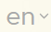
Create new user via 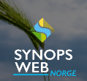and Sign up for a company ID, or log in directly with the username and password of an existing user.
User information can later be changed via in the upper right corner of the screen after logging in. (Here a Workgroup (WG) could also be created to make your established fields and plant protection practices available to a larger group of users.)
How and why to create a workgroup (WG)
When creating a WG, you can share your already defined site/field and/or Application scenario between multiple users. In this way, for example, users within the same geographical area can benefit from already established data in SYNOPS WEB Norway.
You can create a WG by:
  - access your user via
  - select Edit User
  - select Edit workgroup where you can Create new workgroup. You then choose a Name and select Create.
  - Re-enter your user via
  - select Edit User
  - select Edit workgroup
  - Add WG members
  - PS: You must know the relevant users' Username. These will then receive a request in SYNOPS WEB Norway to join the workgroup and can then accept this.
NB. Each user can only be a member of one group. This means that you can only create a group yourself or join a group – not both.
When such a workgroup is established, you can choose to make your Sites/Fields or Application Scenarios available to the members of the WG.
  - For already created items, open the editing capabilities by selecting the featured item and pressing . Choose Edit and check the box Unlock for WG.
  - When creating new items, you can choose to bring in an already existing item from your WG instead of creating a new one. You can also choose to make a newly created item available to your WG by selecting the option Unlock for WG in the dialog box where you create the item.

Workflow
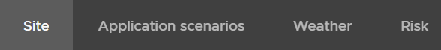
The application has a workflow that starts with:
(1) create one or more Sites (e.g. an agricultural field),
(2) define one or more Application scenarios (e.g. a plant protection strategy) (which is associated with a specific crop),
(3) run a Risk assessment for a given combination of Site and Application scenario with model simulations using one or several years of weather data
These processes are described in the following.

Add Site

Step 1
When you tap Site in the tab at the top of the screen, the list of fields already created appear and with the Add site feature you can add a new site.
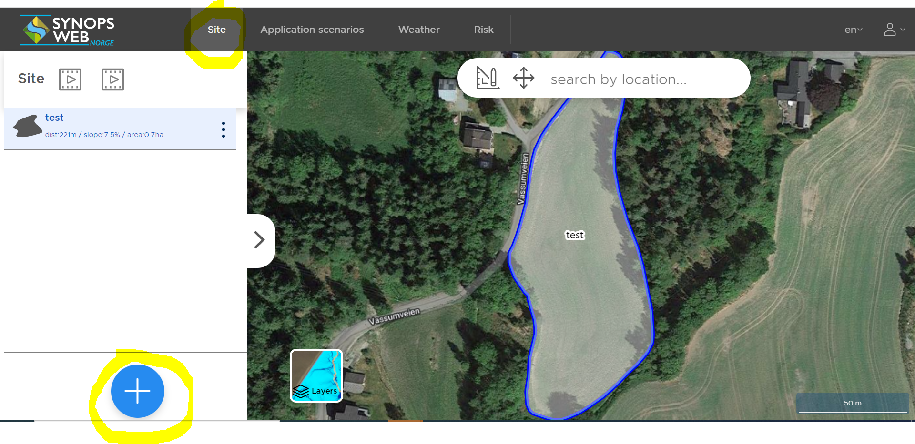

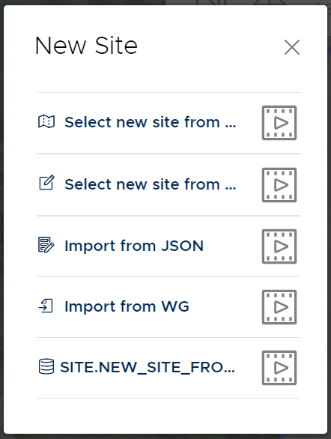
A new Site/field can be added via the functions
- Select on the map; Zoom into the map until the red field boundaries appear OR enter the name of your desired location in the ‘Search by location’ tool in the map window and click on the name to zoom. Click in the desired field.
- Draw field; Zoom to the desired area in the map OR enter the name of your desired location in the ‘Search by location’ tool in the map window and click on the name to zoom. Draw the outline of your field in the map. Chose field within red boundaries. Close the polygon and double-click to exit the shape.
- Import from JSON; Paste text from a JSON file, which is available export format from a variety of mapping software
- Importing from WG; Here, already established fields can be chosen if they have been made available for your workgroup.
Click, hold and drag the left mouse pointer to move/change the map section in the view, when needed.

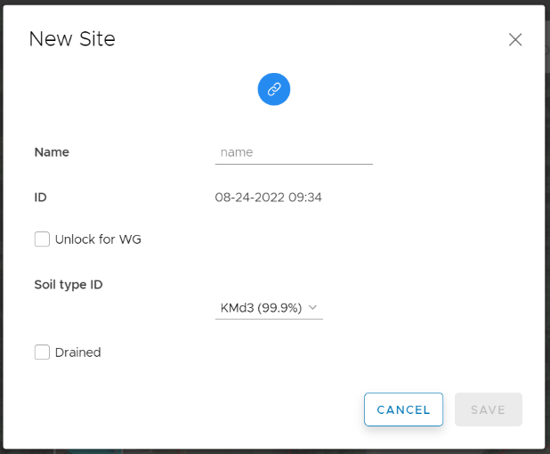
Step 2
A dialog window opens where you do the following:
- Enter the Name for the new field.
- When created site/field is to be available to a workgroup (WG), the Unlock for WG box must be selected. (This assumes that a workgroup has been created)
- If the field is drained, you can select that here and save. Drainage can also be added later.

Step 3
You can find details on topography, proximity to water and soil type for the chosen field by clicking
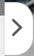 on the right side of the field list. Here you can also make changes manually by clicking 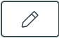 under each theme.

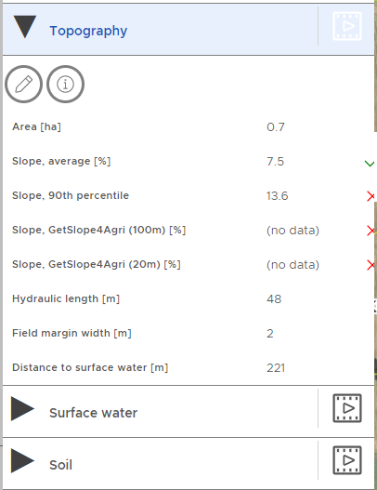
- You can change the slope information used in the risk assessment. The selected parameter is marked in a green check mark.
- Changing the characteristics of the nearest water body can be done under Surface Water.
- If the area is drained, this must be entered manually under Soil. Here, the soil type used in the risk assessment can also be changed. (Default is the soil type with the highest percentage area in the field).

Step 4
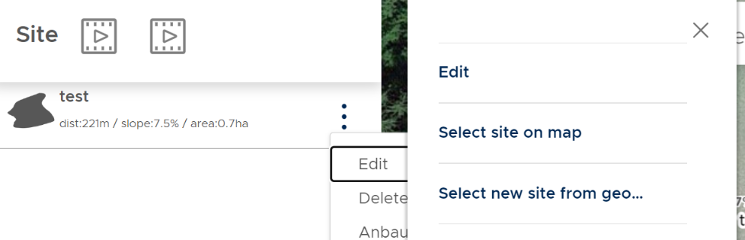
Name, location and field borders can be edited later by selecting the field in the list on the left screen and clicking where you get the options Edit and Delete.
The Edit option includes Edit (rename and link to WG), Select site on map, Draw new field in map (i.e. Select new site from geo..).

Additional information
Additional information from the maps included in the tool can be retrieved via the following functions:
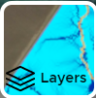 The Layers icon located at the bottom left of the map view and provides access to maps describing the topography, slope towards water bodies and flow patterns on the field.
Map details:
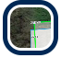Distance to surface water: shows the distance of selected field to surface water. Distance is not given if >150 m.
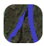 The Waterbodies icon turns on and off map layer for surface water
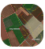 The Sites icon: shows field boundaries and soil types
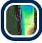 Elevation map for the selected field (opazität: opacity)
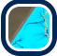 Flow accumulation map and Hydraulic path are shown for selected field and shows the longest hydraulic pathway through the field.
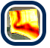Slope map for selected field
In the English version the info button and the 3D symbol for the map details do not work (shows up when clicking on a map detail).

Map type:
The background map can be changed to Google maps or open streetmaps

Add Application scenario
An application scenario consists of three elements that are created in context: Application scenario, Applications and Resources.
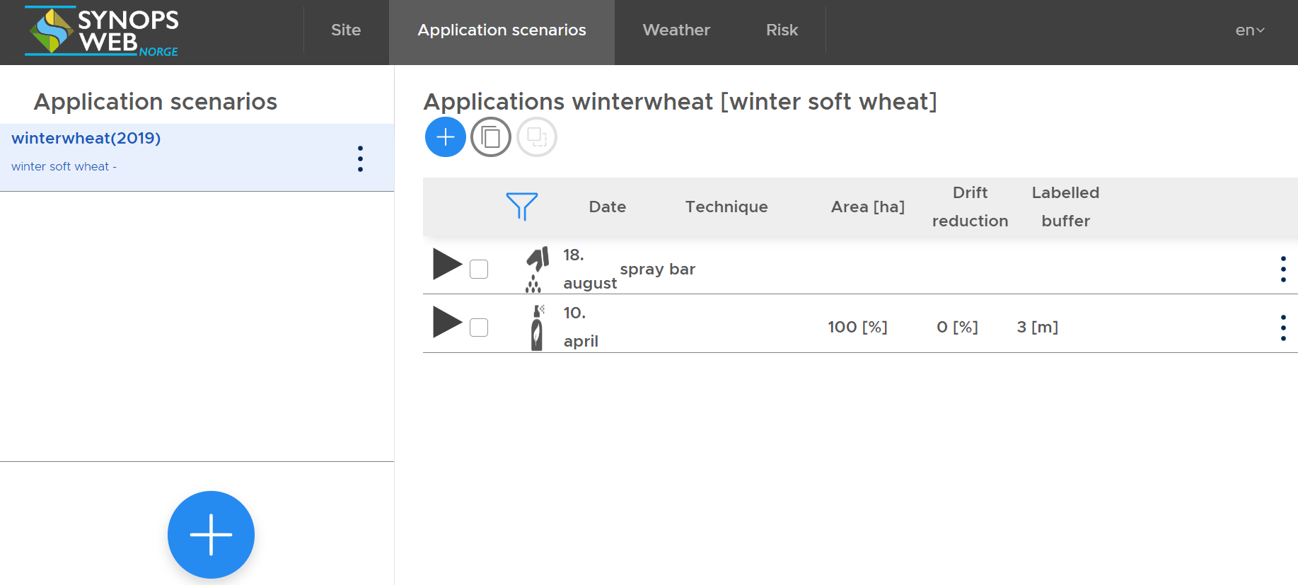
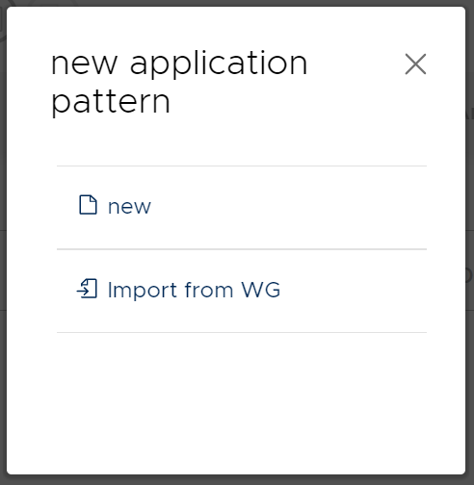

Step 1
Add Application scenario
You can add a new application scenario in two different ways:
- New Application pattern
- Import from WG

When choosing New, you are prompted to link this new application pattern to one of your existing sites/fields. (Nevertheless, any field and application combination can later be used in the Risk assessment).

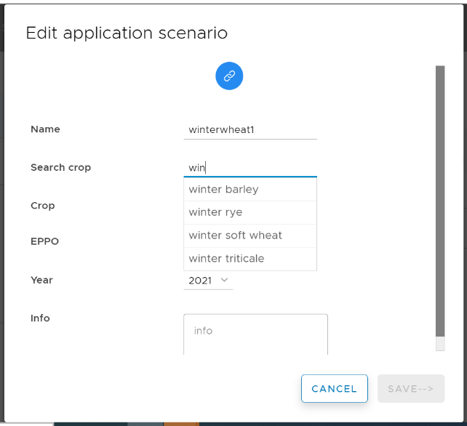
Next, dialog window opens where you do the following:
- Specify the Name of your Application scenario
- Select Crop (start typing the first few letters)
- Select Year

You can make changes later by selecting your Application scenario in the list on the left screen and clicking where you get the options Edit (change culture and link to AG), Copy, Delete and Export.
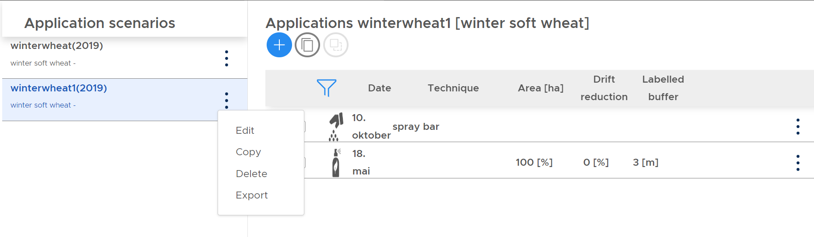

Step 2
Add Applications
After defining an applications scenario, you are prompted to add the different work operations included in the strategy for the selected crop, including the sowing/setting of the crop and the different pesticides sprayings.
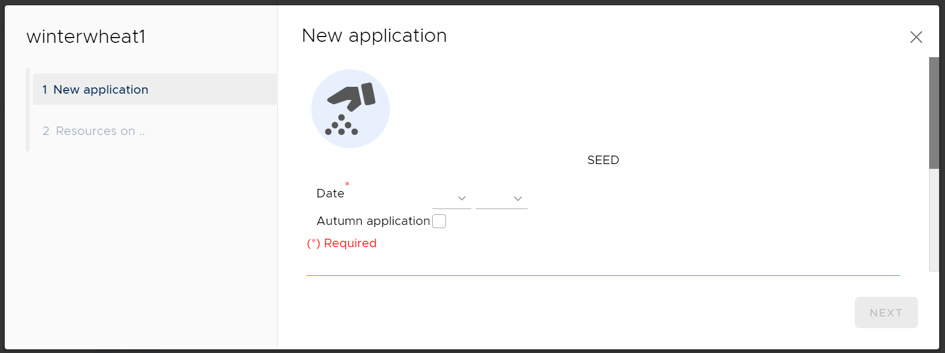

First you need to add sowing of the culture and then define the following:
- Sowing time: Day and Month (when in autumn, check the box Autumn application)
- Mitigating measures: here you can add information about the seedbed and tillage operation when sowing.
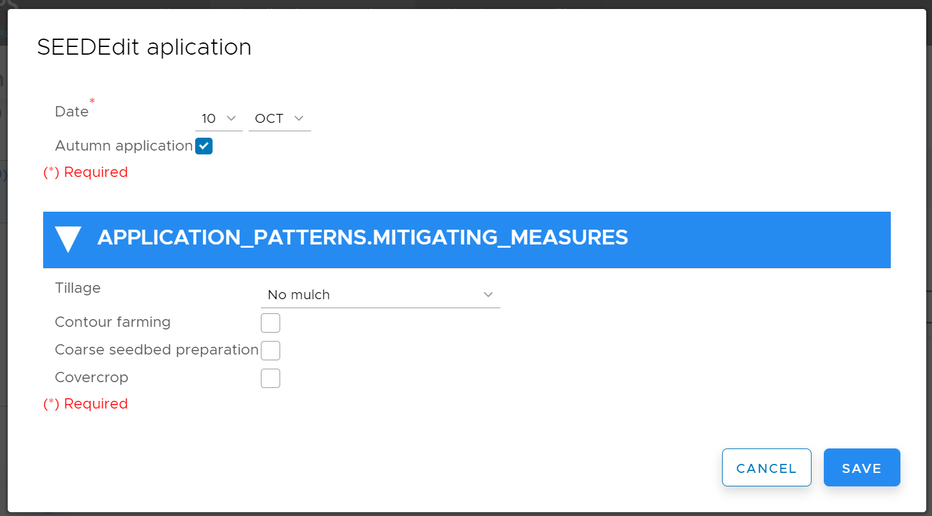
- The tillage drop-down menu includes a selection of options representing different reduced tillage systems. The default No mulch-option represents conventional tillage.Tap Next
Next you are prompted to add more information defined as Resources.
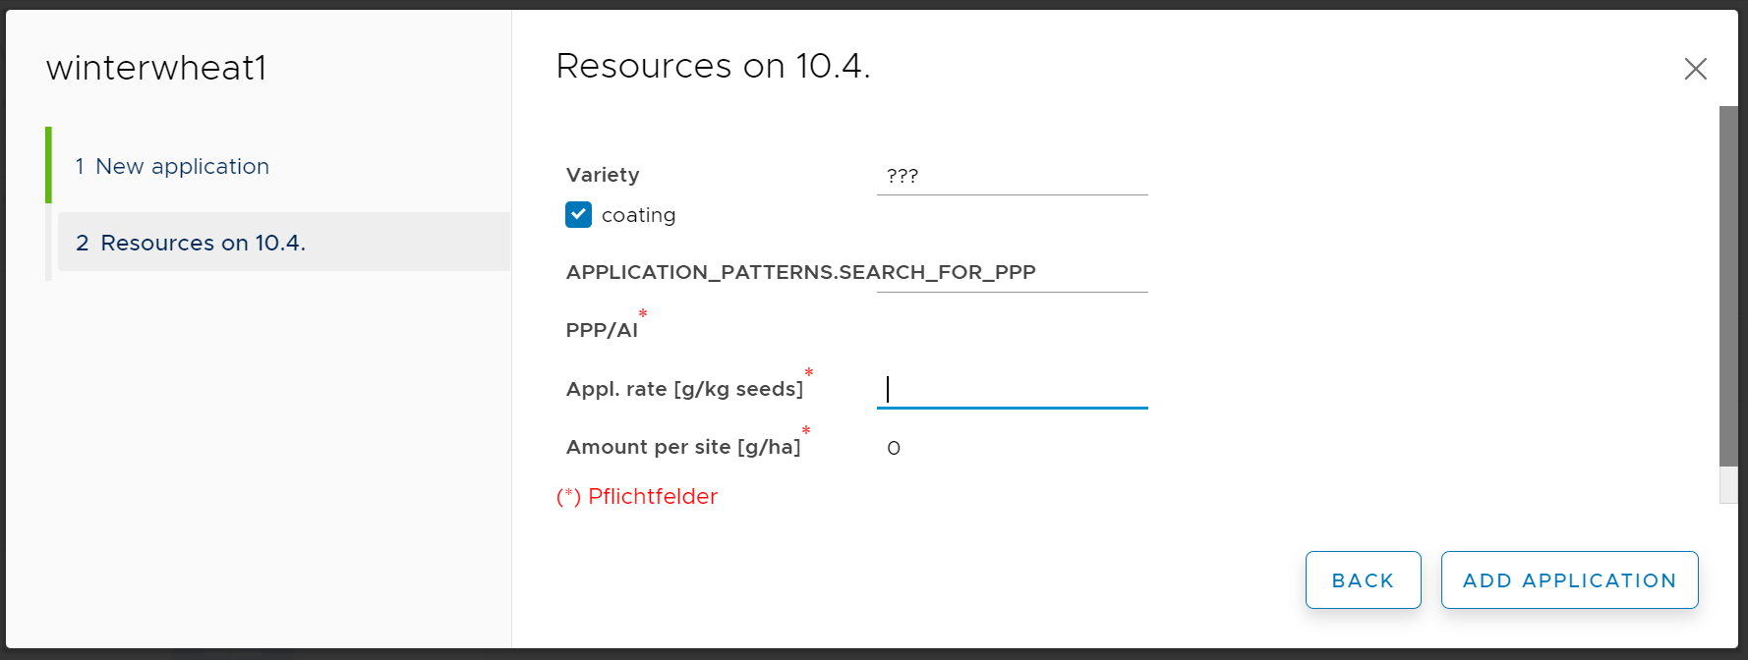
- Selection of variety: you can enter the name of the variety.
- If seed coating was used, check the box for coating to add any plant protection products used for seed or tuber coating and define the plant protection product used (PPP), the application rate and the amount used on the site.

- Tap Add application

Next you are prompted to add New application (PPP = plant protection product); The inputs for (a) New application and (b) Resources are repeated to enter the different spraying times and pesticides included in your plant protection strategy, as outlined below:
- New application
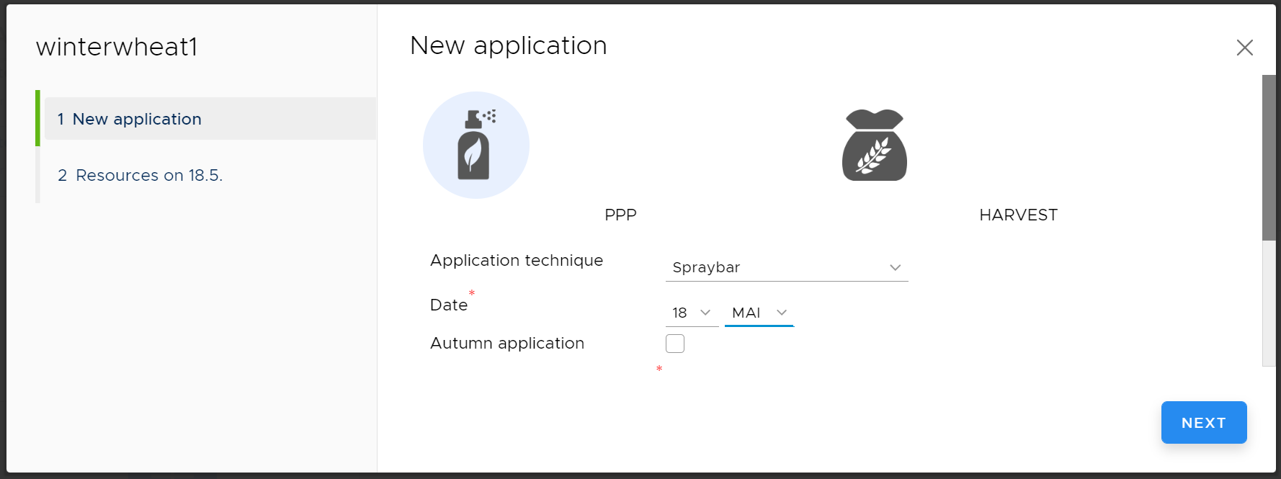
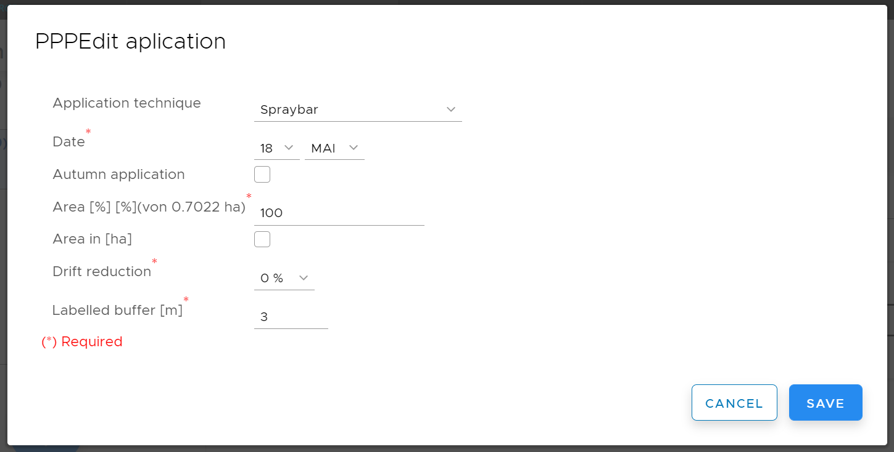
- Choose Application technique (drop down menu)
- Input the Date of spraying (Day and Month)
- Check whether it is Autumn Spraying
- Add the Area sprayed, either in % of total field or in ha. Default is 100 %. Add input as hectares by checking the box Area in (ha) below
- Define the Drift Reduction that was uses in % if you use measures / equipment that has such an effect. The default is 0 %.
- Enter labelled buffer in m: When leaving a spray free zone larger than the mandatory for the selected PPP, edit the Labelled buffer (m)
- Tap Next

- Add resources
Press the blue button to add the name of the PPP or the active ingredient (AI)
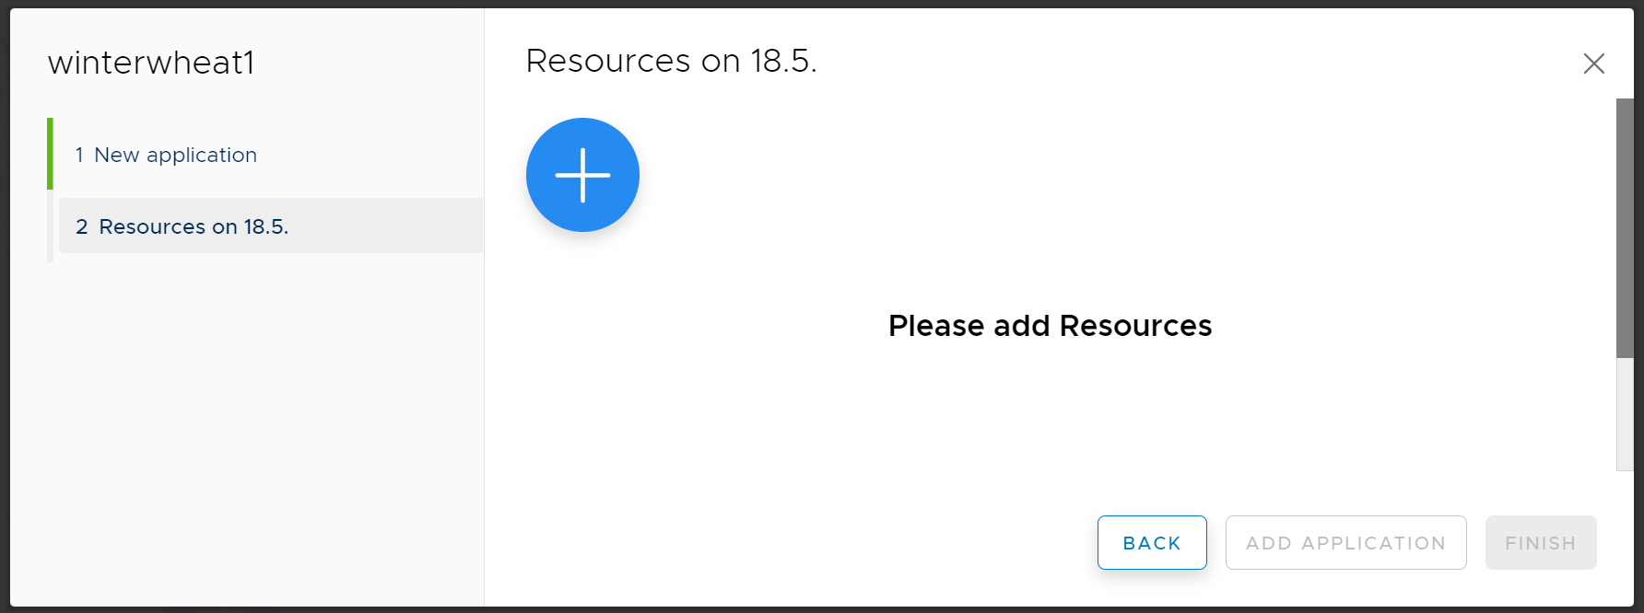

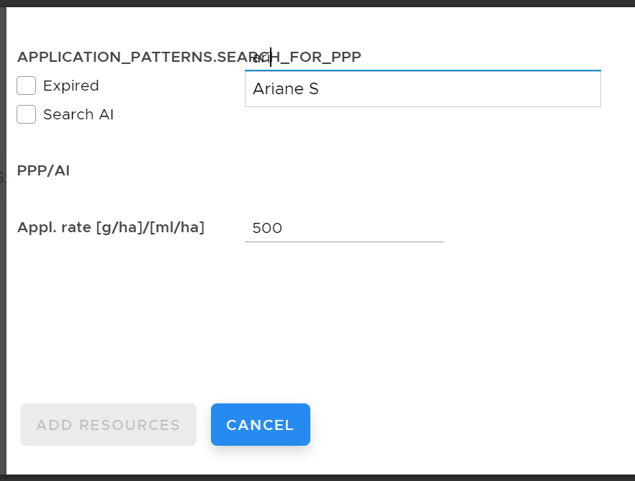
- Search for PPP by starting to enter the name of the commercial formulation. Select by clicking in the list that comes up.
- Tick the box if you want to search for the AI or an expired preparate
- The application rate of PPP is given as grams or mL per hectare (NB)
- Tap Add resources
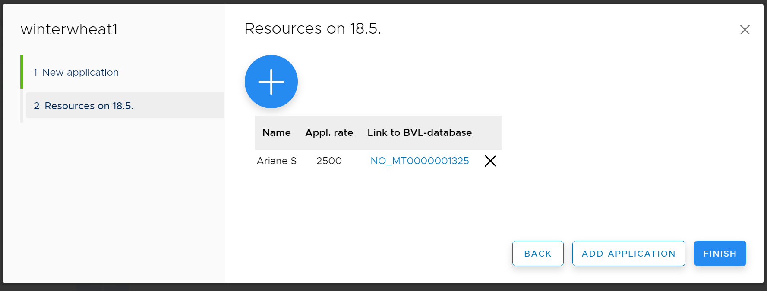
In this view a link to information about the PPP in Plantevernguiden is available. Here details about the application rate, necessary mitigations measures etc can be checked from the label (Etikett) of the PPP. (Only in Norwegian)
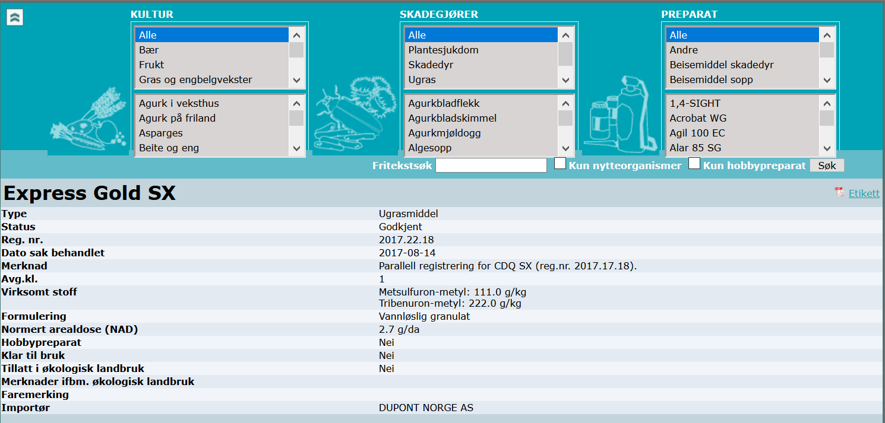

This point (b) is repeated (start by tapping in this view) until all PPPs sprayed on the same day are included
When you have finalized the inputs for one spraying date, you press Add Application. A window opens and youreturn to a) and start adding a New application with another date, working through the needed b-steps as well as outlined in the example above. Press Finish after adding all spraying dates.

When the application strategy is finalized) some key parameters that might impact the risk assessment can be edited from the Application strategy tab and from the Application tab.You can change tillage before sowing:
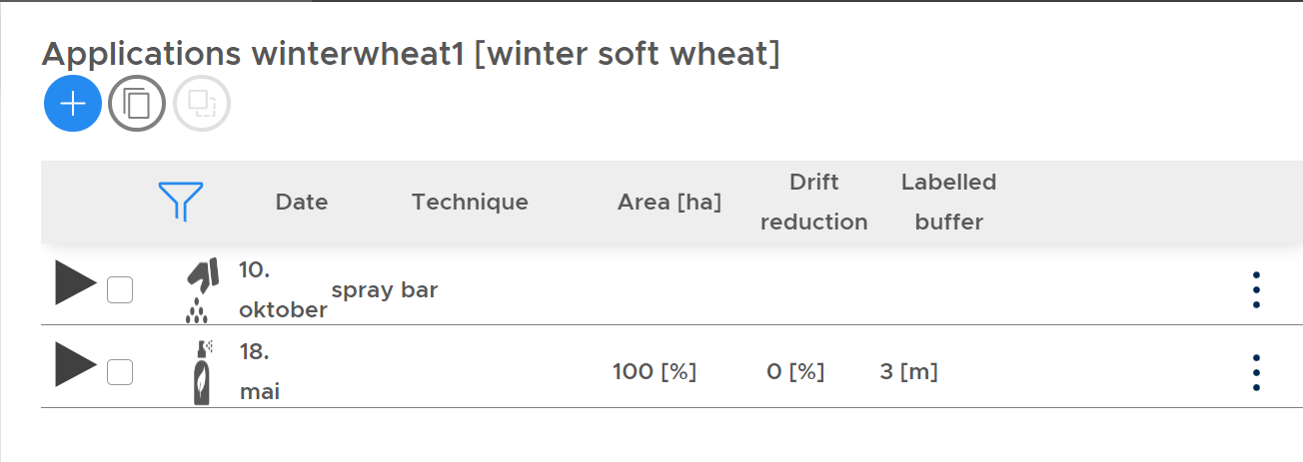

  - And Spraying practice:

Evaluate Weather Data (Weather)
Weather data for one or a period of years are included as input data for the risk assessment. The actual years used in the model simulations are chosen later on, but you can examine some characteristics of the temperature and rainfall patterns for the individual years of available weather data under the heading Weather.
- Detailed curves are shown via: Historical Weather – Custom – define the years to be shown (only the period 2012-2019 is currently available)
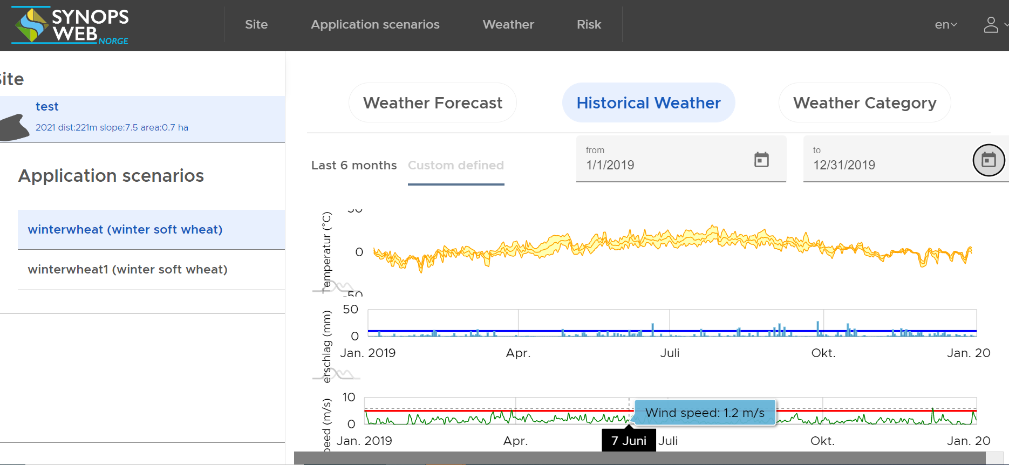
- Information about temperature and precipitation profiles for the different years with weather data available can be found under Weather Category
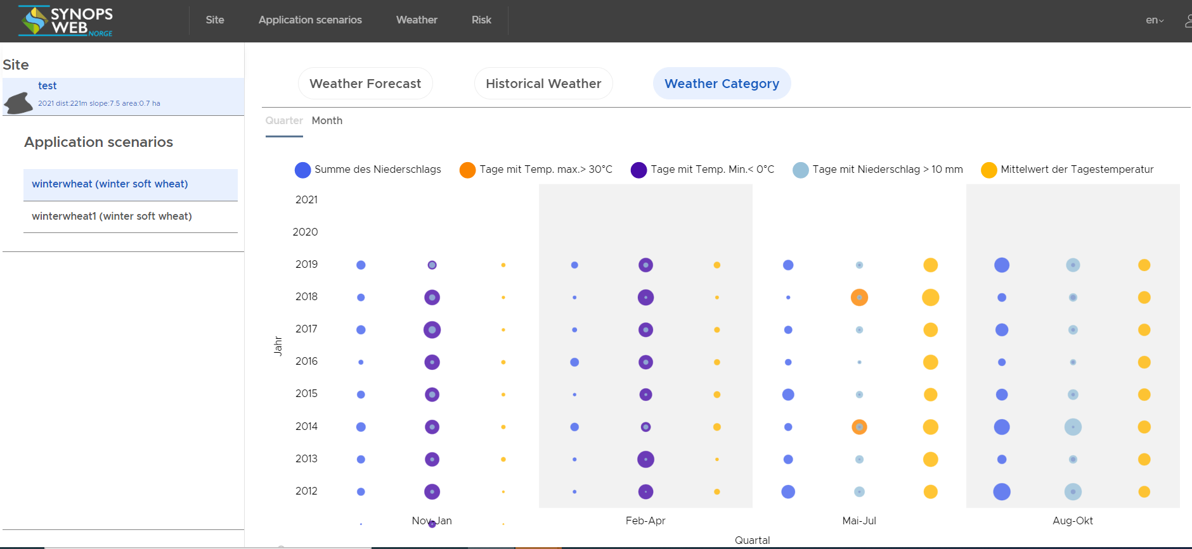
- The option Weather forecast is currently not available.

Perform Risk assessment (Risk)
Here you choose the combination of Site/Field and Application scenario for which you want to carry out a risk assessment
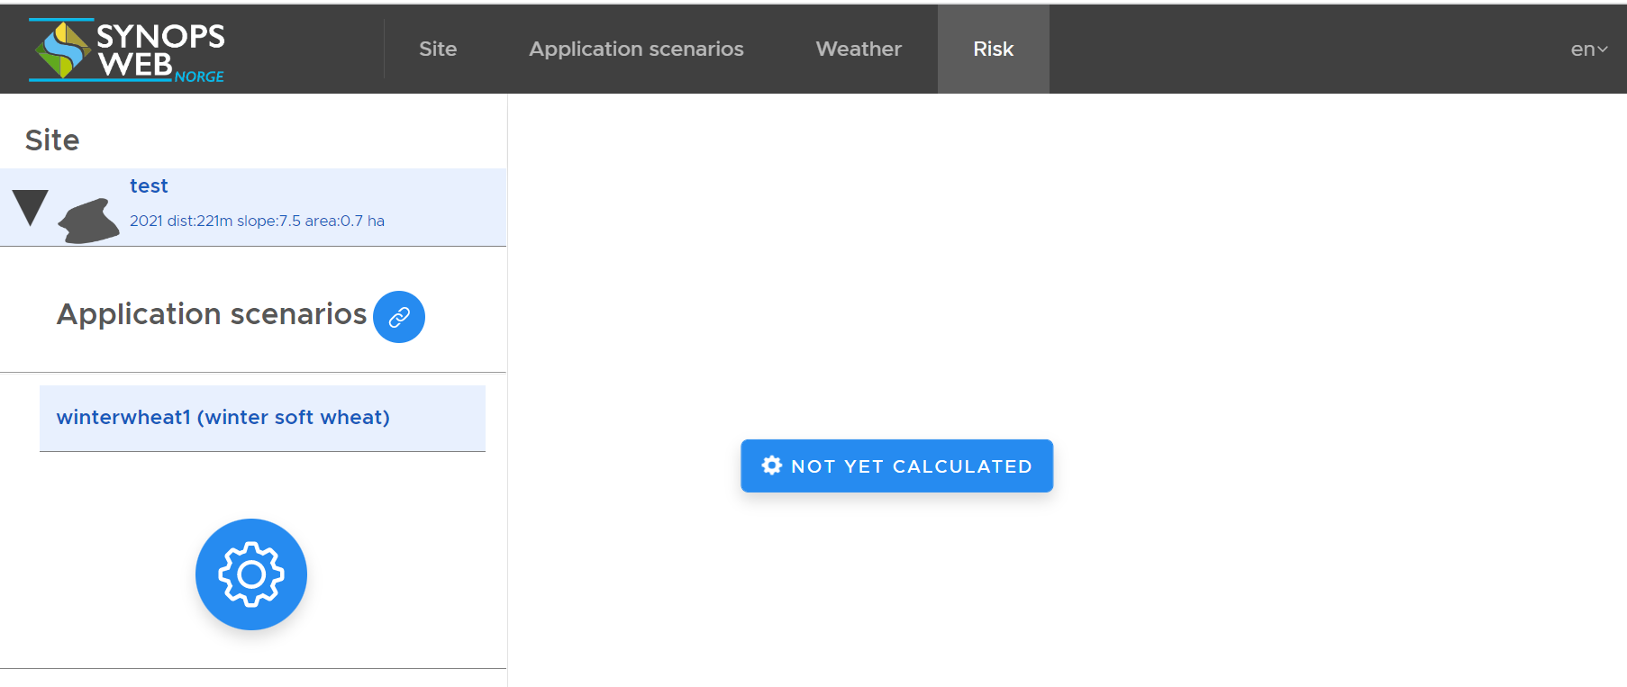

- Select the site/field you want in the left column
- Connect to the desired Application scenario through . (PS. Make sure that only one scenario is connected, i.e. select the wanted scenario, but also deselect those not to be included in the calculation)
- Press to define other inputs to the calculation.
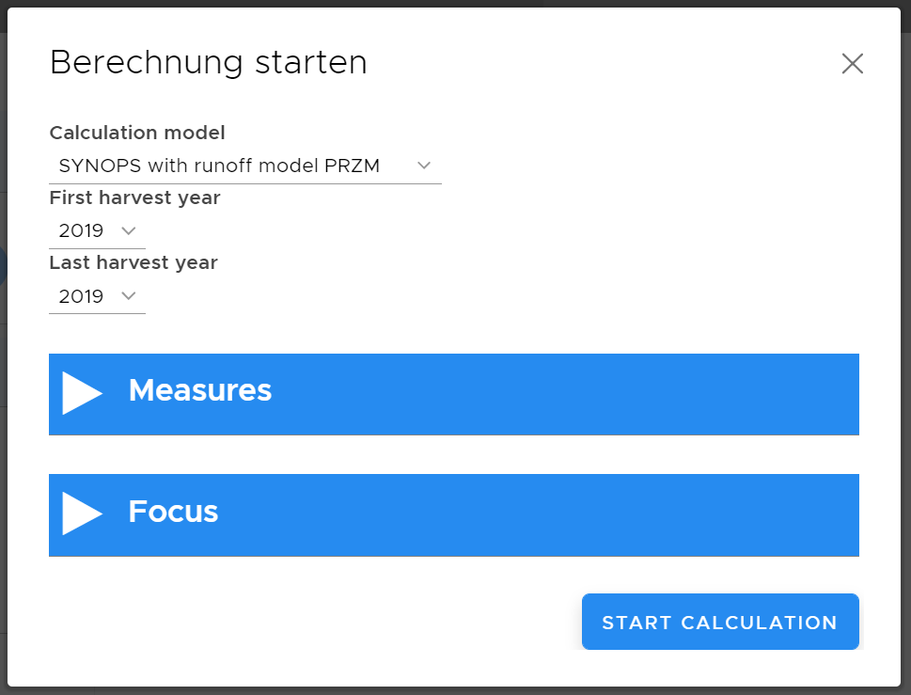
- Select the desired Calculation model for the risk calculation. Default is SYNOPS with runoff model PRZM, which is considered most relevant for most users.
- Define the time period (i.e. one or several years) for which the model simulations are to be run by defining First and Last harvest year. Herein lies the choice of weather data.
- Measures: Specify any measures you have implemented to reduce surface runoff/erosion. (PS. It is necessary to both check the box and add the width and length of the buffer zones.)
- Focus: Gives the possibility to choose other crop parameters (e.g. time for emergence, maturation etc) than the default setting, when this is deemed necessary.
- Start calculation. (It may take a few seconds to run the model).

About the results
The results are shown for total Risk and Risk pr active ingredient (AI) separately.
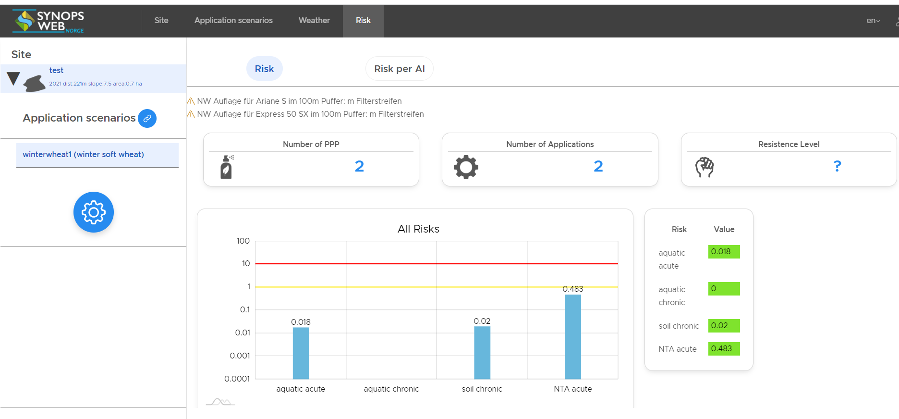
- Risk
  - The number of PPPs and the Number of applications included in your strategy is given at the top. (The Resistance level feature is not yet available).
  - All risks show the calculated ETR (exposure-toxicity-ratio) for the four test compartments included in the simulation; Acute toxicity for aquatic organisms, Chronic toxicity for aquatic organisms, Chronic toxicity for soil organisms, Acute toxicity for non-target arthropods; with colored vertical lines indicating the threshold values for Low risk (1) and High risk (10).
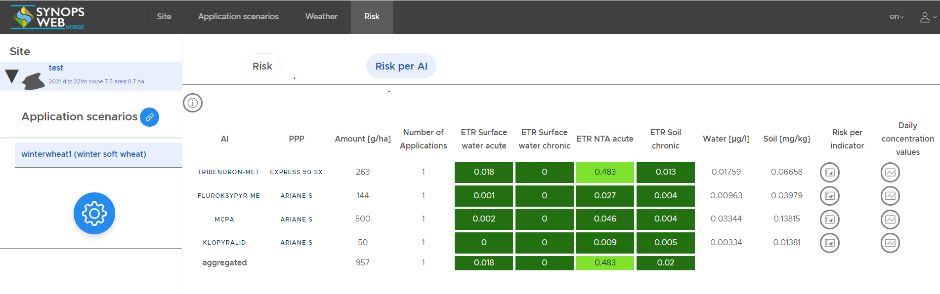
- Risks per AI
  - This table show the calculated risk for the four test compartments included in the simulation (as above) for the individual AI. The results table have color coding where shades of green indicate Very low and Low risk.
  - The simulated a.i. concentrations for the water and soil compartments are included in the table.
  - Figures showing Risk per indicator species (under development)
  - Graphs of Daily concentration profiles show the timing of the simulated peak (max) a.i. concentrations in water and soil

Mitigation measures that can be simulated in the tool
The Pesticide Regulations require pesticide users to take into account the risk of unintended effects in the environment. There are several measures to reduce the risk to the environment, and in SYNOPS WEB Norge the effect of these can be assessed together with good information on site-specific characteristics such as soil and weather conditions, and the properties of pesticides (degradation, sorption, transport). In this way, several different plant protection strategies can be assessed against each other and it becomes possible to choose a pesticide use with a low risk to the environment on the individual field.
Measures to reduce the transport of pesticides in the environment that can be simulated in the risk assessments in the tool include:

Measures to reduce surface runoff:
- Tillage practice
Can be edited/input through the edit-function for the individual sowing.
The tillage drop-down menu includes a selection of options representing different reduced tillage systems. The default No mulch-option represents conventional tillage.

- Vegetated buffer zones
When specifying the parameters for the Risk calculation, filter strips as mitigation measures can be selected.
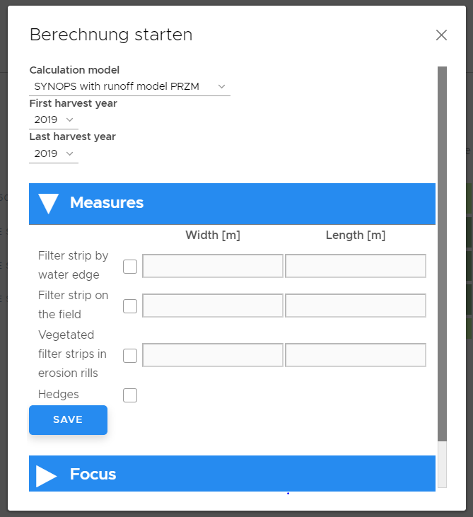
Measures: Specify any measures you have implemented to reduce surface runoff/erosion. (PS. It is necessary to both check the box and add the width and length of the buffer zones.)

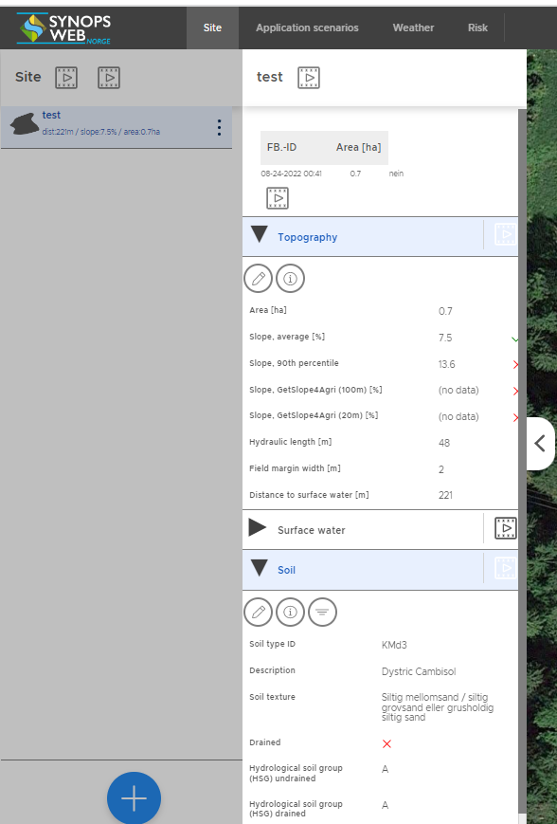
- Take into account that dense soils and steep areas have an increased risk of surface runoff
Information on soil type/soil properties and topography (slope) can be found under the arrow on the left of the map image in the field tab. (Remember to select the appropriate field first).
- Soil types C or B-C often indicate denser soil types that are at higher risk of surface runoff than more sandy soils.
- In model simulations, small surface runoff is often assumed on area with slope <2-4%
- You can also find topography/slope information under the Layers icon in the down left corner of the map view.

Measures to reduce drift:
- Drift-reducing spraying equipment/nozzles
Specified in drop-down menu of the Edit dialog for the individual spraying. Choose between 0, 50, 75, 90 and 95% drift reduction.
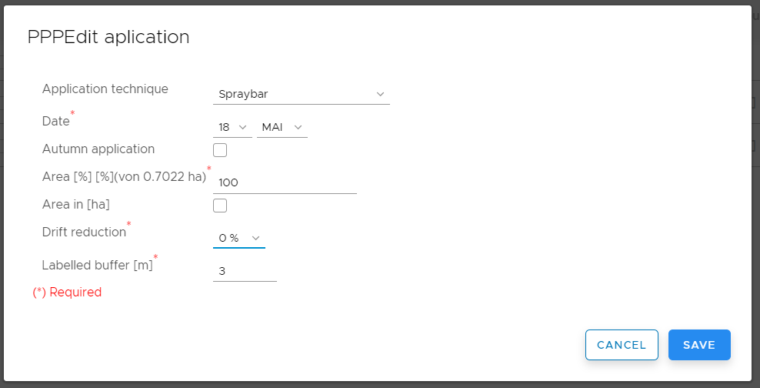

Take into account drift is a very important loss path from area with a short distance to surface water.
Information about distance to water can be found under the Layers icon in the bottom left corner of the map view.

Key info about the data in SYNOPS WEB Norge
Data from the digital soil map (https://nibio.no/tema/jord/jordkartlegging; NIBIO) and the weather stations of the Agricultural Meteorological Service (LMT; https://lmt.nibio.no/; NIBIO) as well as a link to information about the approved pesticides (www.plantevernguiden.no; NIBIO), is included in the tool. Other map data includes data on area figures from AR5 (https://nibio.no/tema/jord/arealressurser/arealressurskart-ar5; NIBIO), as well as water from N50 map data (Norwegian Mapping Authority) and terrain information from the DTM-10 terrain model (Norwegian Mapping Authority).
The user of the tool enters information about culture and plant protection practices at the field level.
The models included in Synops web Norge use these data to model environmental risks for a selected culture and spraying practices, by calculating concentrations of pesticides in soil and nearby water bodies (stream or water) and comparing these with the toxicity of the agent to selected organisms in soil and water.

