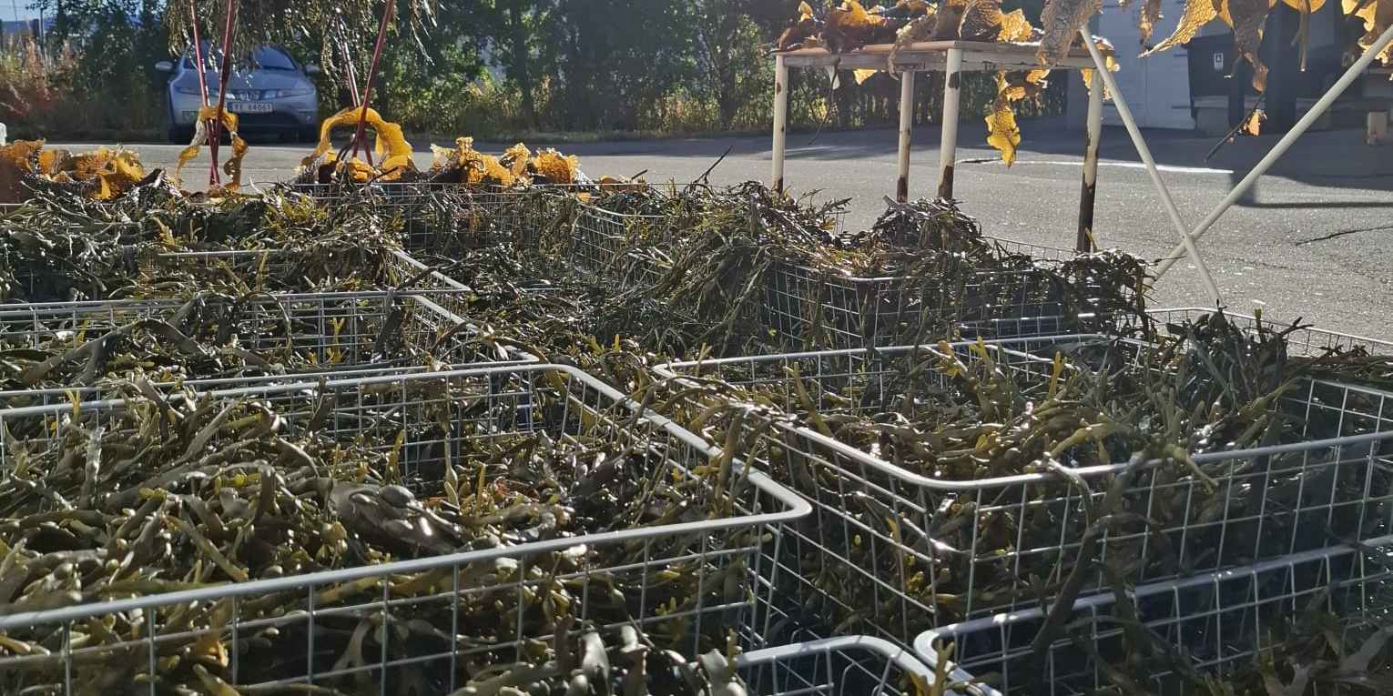
Can marine algae make wood products fire-resistant?
The NordicWood project explores fire-safe, bio-based wood insulation made from wood chips, cellulose nanofibrils and marine algae processing residues. Unexpectedly, wood-algae composites show remarkably high fire resistance, challenging the idea that wood-based materials must burn easily. The project investigates the mechanisms behind this behaviour and how it can be engineered into a lightweight, circular insulation material for Nordic buildings.
The project offers hands-on master’s thesis topics in materials science, wood technology, fire performance and sustainable construction.
For further information, contact
Stephen Amiandamhen
stephen.amiandamhen@nibio.no
41363419

