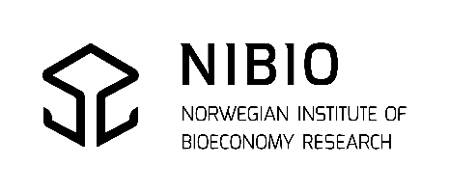 |  |  | ANALYSIS REQUEST FORM  Pesticides in soil and other environmental samples
Client: (WRITE LEGIBLE) |  |  |  |  |  |  | Copy recipient:  Name:  E-mail:
Company:
Contact person:
Address incl. country:
E-mail: |  |  |  |  |  |  | Phone:
Customer reference* (printed on the report and the invoice):  *Max 1 unique reference per order (per request form) |  |  |  |  |  |  | Attn. (printed on the report and the invoice):
Invoice address:
Sampling place: |  |  |  |  |  |  | Collected by:
 | Sample material / description |  |  |  |  | External sample ID(max 20 characters) |  |  |  |  | Collection date
1
2
3
4
5
6
7
8
9
10
Analytical method(s): |  | M93 and M86  Both multimethods; GC-MS/MS &  LC-MS/MS |  |  |  |  | M93  GC-MS/MS multi |  | M86  LC-MS/MS multi |  | M77  LC-MS/MS Linear alcohol ethoxylates
M121 Screening EFS pesticides (around 800 compounds) LC-HRMS |  |  |  | M125 Aminopyralid and clopyralid in soil, compost and fertilizer (liquid and pelleted) LC-HRMS |  |  |  |  | Other methods:
The standard reporting deadline is 3 weeks. A shorter deadline must be agreed upon in advance and can be
accepted for a surcharge when adequate capacity of the laboratory. For shorter deadlines, the laboratory must have
received the samples before 12:00 (noon) or as otherwise agreed.
Reporting deadline (business days): |  |  |  |  | Standard, 3 weeks |  |  | 1 week  (25% surcharge) |  | 48-72 hours  (50% surcharge)
Any risk of contamination from concentrated plant protection products or spraying solution from spraying equipment? No Yes
Additional information:
Is a control/assessment of results according to regulations desired? Please state the relevant regulation(s):
Ref. agreement/agreed deadline/contract/
project/contact person at NIBIO:
For more information about terms and conditions, please visit our website: https://www.nibio.no/lab/en
Signature and date:
Send samples to: NIBIO Biotechnology and Plant Health,
Dept. Pesticides and Natural Products Chemistry Phone: E-mail:
ATT.: PRØVEMOTTAK, Høgskoleveien 7, 1433 ÅS, Norway +47-40604100 pesticidlab@nibio.no
NIBIO Sample-ID: |  |  |  |  |  | Recieved: |  |  | Registered:

